I. Government vs. a State of Nature
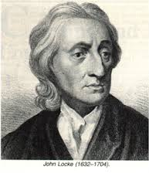
John Locke
His political theory of government by the consent of the governed as a means to protect “life, liberty and estate” deeply influenced the United States’ founding documents. His essays on religious tolerance provided an early model for the separation of church and state.

Democracy: Rule by the People
- From the Greek words “Demos” = People; and “Kratos” = to rule;
- First appeared in Athens, Greece over 2400 years ago.

How does a direct democracy differ from a representative democracy?

Which type do we have in the United States?

What is another term for a Representative Democracy?
a. Political thinker John ___________ said government is better than living in a state of __________.
b. Locke said governments exist to ___________ our ________ rights (life, liberty property)

c. Locke said the only legitimate way for a government to gain power is by _________ of the ____________.

II: Types of Governments
a. Definition of Government -

b. Types of Government systems

1. Democracy -
2. (Absolute) Monarchy -

3. Dictatorship –

4. Oligarchy –

6. Theocracy –

III. Fundamental Political Principles: (SOL 2.a)
The Magna Carta, written in 1215 by a group of 13th-century barons to protect their rights and property against a tyrannical king. There are two principles expressed in Magna Carta that are found in our Constitution today:
"No freeman shall be taken, imprisoned, diseased, outlawed, banished, or in any way destroyed, nor will We proceed against or prosecute him, except by the lawful judgment of his peers or by the law of the land."
"To no one will We sell, to no one will We deny or delay, right or justice."
Where are these rights found in the US Constitution?

What fundamental political principal was first outlined in the Magna Carta?

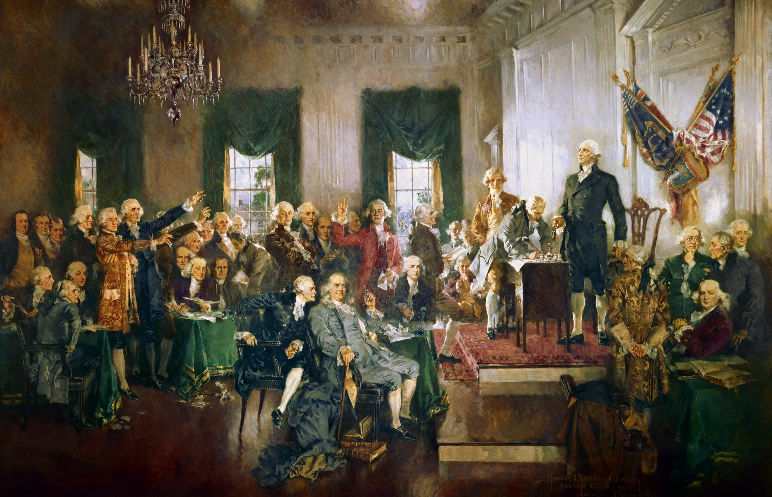
The United States Constitution:
- Consists of 1 preamble, 7 articles, 27 amendments.
- Written in 1787, contains 4, 543 words.
- Is the supreme law of our land

a. Consent of the Governed -

b. Limited Government –

c. Rule of Law –

d. Democracy -

e. Representative Government –

IV. The Constitution of the United States of America (SOL 2.c)
The _____________ to the Constitution of the United States of sets forth the ______________ and ________________ to be served by the government.

b. The _____________________ to the Constitution of the United States of
America expresses the __________________________________________________.

c. Purposes of Government as listed in the Preamble
1.
2.
3.
4.
The words “We the People…” illustrate which fundamental political principle?

Which goal of the Preamble is fulfilled if the Governors of VA and MD work together to solve a common problem?

Which goal of the preamble is represented if Congress votes in spend more money on the military?

Government providing schools, hospitals, and fire departments is which goal of the preamble?

Which document completes the graphic below?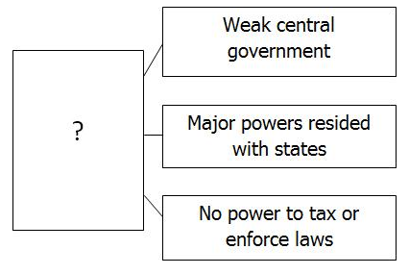
5.
6.

d. The Preamble to the Constitution of the United States of America begins,
“_________ ___________ ________________________,” which establishes
that the power of government comes from the ____________________________.

V. Founding Documents: (SOL 2.b) How did the following documents influence the United States Constitution?

a. The American Constitutional government is founded on
_______________________ articulated in earlier __________________________.

b. Charters of the Virginia Company of London
1.
2.

c. Virginia Declaration of Rights
1.
2.
d. Declaration of Independence
1. Stated grievances against the King of Great Britain….

2. Affirmed certain unalienable rights…
Which document would best be described as “affirming the individual worth and dignity of all people”?

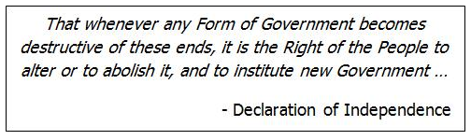
The quote above best illustrates which fundamental political principles?

The following words are from which early document? 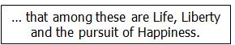

Define Amendment:
e. Article of Confederation
Established the first from of national ________________________ for
the independent states.
1.
2.
3.

f. Virginia Statute for _______________________ Freedom
1.

g. Constitution of the United States of America
1. Established the structure of the United States government
2. Guarantees __________________ under the law with
_____________________ rule and the rights of the ___________________________ protected
3. Affirms individual ________ and ____________ of all people
4. Protects the fundamental freedoms of ____________, ____________,
____________, ____________, and ____________.

VI. The Amendment Process (SOL 2.c)
- The amendment process is ______________________
- To date there are only ___________ amendments

a. Federal Amendment Process
  - Proposal:
  - Ratification:

b. Constitution of Virginia
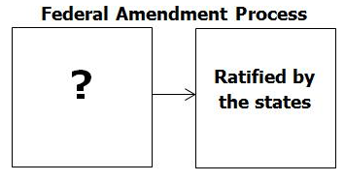What would complete the box above?

White House Fun Facts
- There are 132 rooms, 32 bathrooms, and 6 levels to accommodate all the people who live in, work in, and visit the White House. There are also 412 doors, 147 windows, 28 fireplaces, 7 staircases, and 3 elevators.
- At various times in history, the White House has been known as the "President's Palace," the "President's House," and the "Executive Mansion." President Theodore Roosevelt officially gave the White House its current name in 1901.
- With five full-time chefs, the White House kitchen is able to serve dinner to as many as 140 guests and hors d'oeuvres to more than 1,000.
- The White House requires 570 gallons of paint to cover its outside surface.
- For recreation, the White House has a variety of facilities available to its residents, including a tennis court, a jogging track, swimming pool, Movie Theater, billiard room, and a bowling lane.

- Proposal – action by __________________________ or convention
- ____________________________ - by the voters of Virginia

VII. Intro to the 3 Branches of Government SOL (6.a)
A. The United States Constitution establishes 3 branches of government
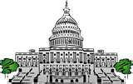
B. The ______________ Branch (Article I)
1. Made up of the United States ______________
a. U.S. ____________
b. House of ______________
c. Main function is to ______________ the laws for the nation

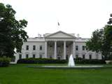
C. The ______________ Branch (Article II)
1. Headed by the _______________ and Vice _______________
2. Main function is to _______________ or _______________ out the laws.

D. The ______________ Branch (Article III)
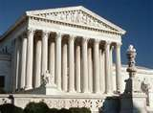
1. Headed by the U.S. ___________ Court
2. Main function is to ___________ laws (make sure they are constitutional)

VIII. Separation of Powers & Checks and Balances (SOL 6.b)
Checks and Balances 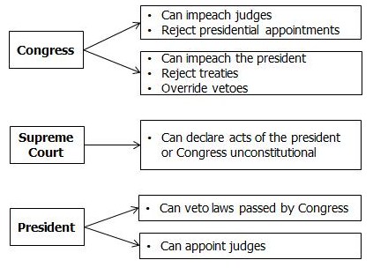
According to the illustration which branch has the power to veto bills?

Which branch has impeachment powers?

_______________________________________

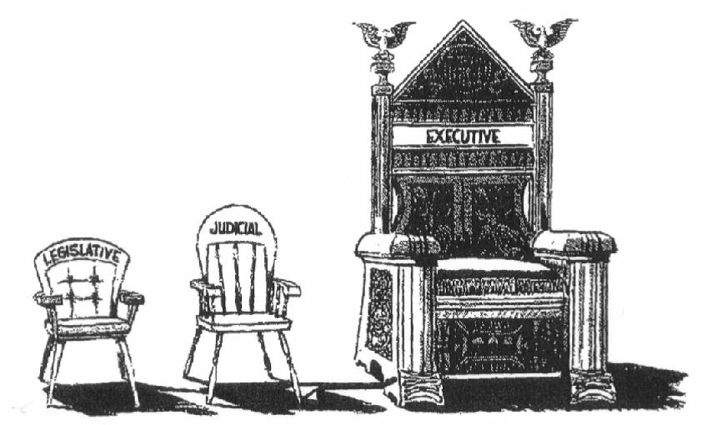
Looking at the cartoon above, what is the cartoonist’s opinion of separation of powers?

Is this cartoon an accurate representation to the power of the three branches? Why or why not?
a. The powers of the national government are ______________ among _______ branches of government in ways that limit any one branch from ______________________ its
power.

b. ___________________________ of Powers –The Constitution of the United
States, in Articles I, II, and III defines the powers of the _______________________, ______________________, and __________________ branches of national government.

c. Checks and Balances -

d. ___________________________ branch
1. ________________________ checks the President when Congress:
a. ____________________________ Presidential vetoes
b. ______________________ and _______________ a President

2. The ________________________ checks the courts when Congress:
a. ____________________ or refuse ________________________
b. _____________________ and ________________ a Judges/justices

e. ____________________________ branch
1. __________________________ checks Congress when the President:
a. Proposes ______________________________
b. Prepares an ___________________ budget for Congress to
approve.
c. ______________________ a special session of Congress
d._______________ legislation Congress passed

2. ___________________________ checks the courts when the President:
a. Appoints ______________________________________

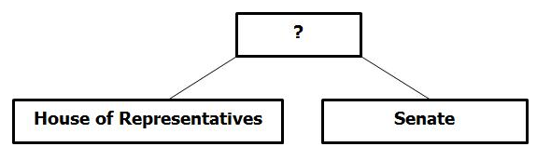Which term would complete the box above?

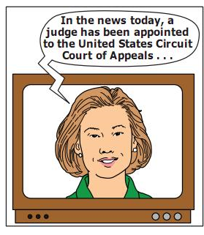
Which branch has the authority to appoint federal judges?

Which branch is being checked?

f. _______________________________ branch
1. The _______________________ check Congress when judges/justices:
a. Declares acts of Congress __________________________
2. The _____________________ check the President when judges/justices
a. Declares executive actions _________________________

Notes:

