Name__________________________ Date______________
Founding Political Principles
Read pages 86 – 88 and answer the following questions.
- After reading “Civics in Practice” on page 86 what gives the U.S. government the right to tell you what to do?

- After reading “Pilgrims agree to be governed” on page 86 briefly describe the Mayflower Compact.

- After reading “Mayflower Compact” on page 87 explain how the Mayflower Compact influenced the Declaration on Independence and the U.S. Constitution.

- After reading “Government Power from the People” on page 87 explain consent of the governed. (Hint: Last sentence on page 87)

- After reading “Reaching the goals of the Constitution” on page 88, list the 4 principles upon which our Constitution is based.

Part II: True / False – Identify each of the following as true (T) or false (F).
_____ - A legitimate government is one that takes power through force.
_____ - The Magna Carta was a document that limited the power of King’s.
_____ - The Mayflower Compact is an example of a social contract.
_____ - Consent of the governed means “without the people’s permission.”
_____ - The U.S. Constitution protects minority rights over majority rule.
Part III: Political Cartoon - Look at the cartoon and answer the following questions.
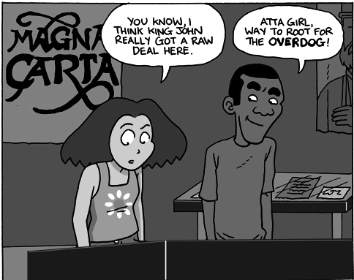
- What impact did the Magna Carta have on the power of Monarchs (Kings)?
  - It increased the power of the King
  - It limited the power of the King
  - It established the King as the head of the nation
  - It removed the King from power

- What influence did the Magna Carta have on the U.S. Constitution?
  - It set up the 3 branches of government
  - It established a King in the United States
  - It established the principle of limited government
  - It gave the president a life term in office like a king

